Our Class Reunion Information

Name: ______________________________ Married Divorced Single Widow
Address:____________________________________________________________
Email Address:_________________________________
Attending: _____Yes I am attending ___# attending Enclosed:________($35 per person)
_____Yes I do have special dietary needs. Call me: phone________________
____ Sorry, I cannot attend
Please RSVP no later than July 2nd, 2026

Please share and update information:
(i.e., spouse, children, grandchildren, occupation, retirement, etc.) Even if you are NOT attending, this information will be shared in our class booklet. (Unless otherwise requested)
________________________________________________________________________________________________________________________________________________________________________________________________________________________________________________________________________________________________________________________________________________________________________
Please answer at least one the following questions, honestly!
1. If you had the opportunity to go back in time (McFly!!), what advice would you give your younger self?
______________________________________________________________________________________________________________________________________________________________________________________________________________________________________________________________________________
2. What is your best/fondest memory of your years at Vermilion Schools? Or funniest…..
______________________________________________________________________________________________________________________________________________________________________________________________________________________________________________________________________________
3. What’s on your bucket list? Travel… Skydiving…winning the Nobel Peace Prize?
______________________________________________________________________________________________________________________________________________________________________________________________________________________________________________________________________________
4. What teacher or classmate made a positive difference in your life? ____________________________________________________________________________________________________________________________________________________________________________________
Please send this information and Payment: one of the following ways:
- A check to: Janet Tansey 52898 Darrow Rd Vermilion Ohio 44089:
WE will accept Checks payable to: Janet Tansey;
- Venmo: @JANET-Tansey 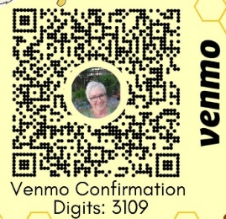

- Zelle: JANET TANSEY jantanze@aol.com (Northwest Bank) 